**Press release***Trade press*

**Samuel Tevosyan is new CEO of Kautex Maschinenbau in Russia**

**Samuel Tevosyan took over the management of the Kautex subsidiary in Russia in July. The sales professional has been appointed to further extend the packaging business in Russia and its neighboring states. Russia is one of the core markets of the Bonn mechanical engineering company that specializes in the development and construction of highly efficient extrusion blow molding machines and continues to play a leading role worldwide in this sector.**

Samuel Tevosyan has many years of management and sales experience and knows the plastics industry and the Russian market very well. Most recently, he was sales director in North Russia in the non-PET division of one of the world's biggest system providers for injection molding technology and he succeeded in acquiring significant contracts in the non-PET sector in Russia.

Together with the Russian Kautex team, Samuel Tevosyan will expand the sales of Kautex products and services in Russia and neighboring countries. In future, the specific circumstances, requirements and products of the individual customers will be even more in focus than before. Kautex Maschinenbau has recently made successful advances in the packaging sector with the development and expansion of individual machine solutions.

Thomas Hartkämper, CEO of the Kautex Group, believes the new appointment offers the opportunity of further extending business in Russia: "Kautex is one of the world's most important providers of system solutions in the field of extrusion blow molding technology. We construct highly efficient and sustainable machine solutions that provide our customers with important competitive advantages. Their success is our endorsement. Russia and the neighboring states are a particularly important future market for us. We are happy to have found in Samuel Tevosyan a dynamic head of our Moscow subsidiary who has the necessary market and product knowledge as well as many years of sales experience."

Samuel Tevosyan is looking forward to his new challenge and being part of the international team of experts at Kautex. "It's a great honor for me to lead the Russian Kautex subsidiary into a strong, stable and successful future."

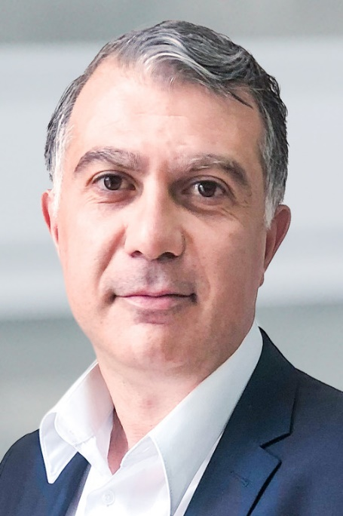 **Samuel Tevosyan**

**About Kautex Maschinenbau**Eight decades of providing its customers with innovative products and services have turnedKautex Maschinenbau into one of the world's leading companies in extrusion blow molding technology. With customers that include major automobile manufacturers and suppliers, as well as companies working in the packaging industry. All of them have come to rely on the knowledge and experience of a brand that stands for both quality and reliability. In addition to its HQ in Bonn, a Customer Service Center in Berlin and regional offices in the USA, Russia, China, Italy, India, Mexico and Malaysia, Kautex Maschinenbau operates an extensive global network of service and distribution offices. **Contact details**

**Christian Kirchbaumer**  
Head of Marketing Communications

**Kautex Maschinenbau GmbH**  
Kautexstr. 54  
53229 Bonn  
Germany

T +49 228 489370

christian.kirchbaumer@kautex-group.com